Data collection sheet – the impact of trees on temperature.

The goal of your lesson today is to collect data on the impact that trees around your school have on the temperature of that location.
The aim is to consider;
- How trees affect temperatures during EXTREME conditions such as a heatwave and:
- If our school should be altered to accommodate more trees to be better adapted to heatwave conditions.
Task
- Select a large mature tree within the school grounds.
- You could use the FSC tree identification guide to find out what sort of tree it is
- Choose one of the two methods below for taking your temperature and light measurements

METHOD 1 – Linear transect | METHOD 2 - Radial
- Place a tape measure either side of the tree around its stump, 25m on either side.  - Start at the stump and measure both the temperature and light levels. Don’t forget to allow the thermometer time to adjust before taking the reading.  - Move five meters away and repeat the temperature and light measurements.  - Repeat until you are 25m away from the tree.  - Once done, repeat the process on the other side of the tree. You should end up with ten results. | - Collect the temperature and light readings in concentric circles around the tree.  - Start at the stump and take 4 readings around the base of the tree, perhaps at all major points of the compass.  - Move out 3 to 5m (depending on the size of the tree) and take 4 more readings around the tree.  - Repeat more times until you are clear of the tree canopy/crown.
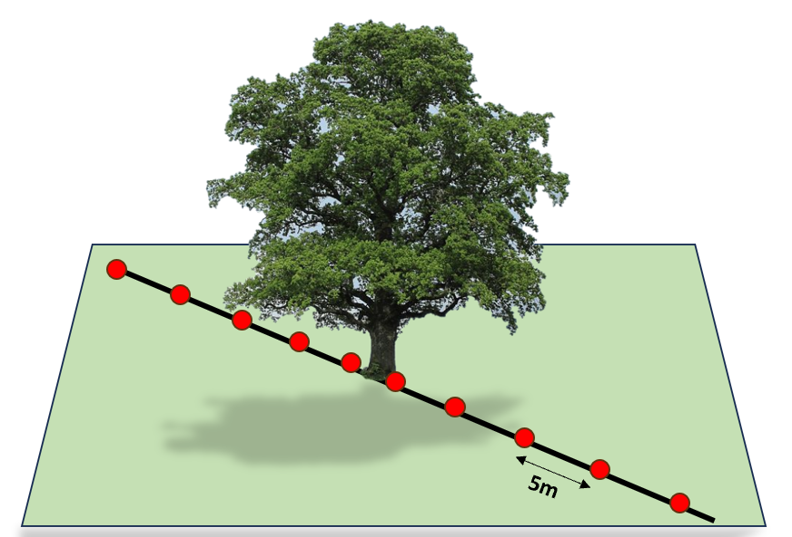 | 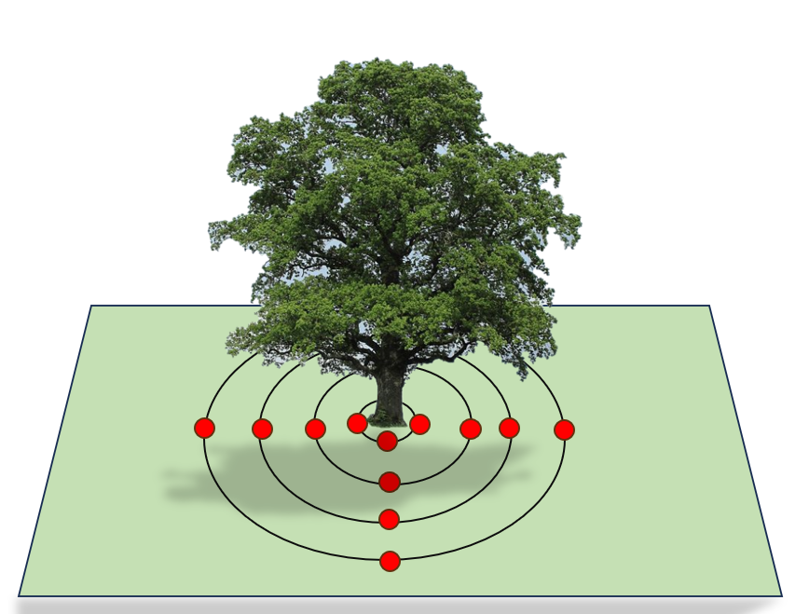

Method 1 – Linear Transect

 | Light | Temperature
1 |  |  | Furthest from Tree Stump
2
3
4
5 |  |  | Closest to tree stump
6 |  |  | Closest to tree stump
7
8
9
10 |  |  | Furthest from Tree Stump

Method 2 – Radial
Temperature measurements
 | 1 |  | 2 |  | 3 |  | 4 |  | Average (mean)
Base of tree tump
5m away from base
10m away from base
15m away from the base
20m away from the base
Increments above can be adjusted dependent upon the size of the tree and its crown.
Light measurements
 |  | 1 |  | 2 |  | 3 |  | 4 |  | Average (mean)
Base of tree tump
5m away from base
10m away from base
15m away from the base
20m away from the base

